Applications:PacketTracer

Capstone Project 1: Install and Use Packet Tracker
Module: 1
Project: Capstone Project 1 – Install and Use Packet Tracer
Computer Used: Windows 11 Pro, Lenovo legion pro 7.
• What is the first step in deploying a Packet Tracer network?
Drag devices from device type selection box into the workspace, this begins the deployment of the network environment.
• When looking at a physical device’s tabs in Packet Tracer, which tab is considered the learning tab?
Physical tab is the learning tab as it shows the physical layout, modules, power options and helps visualize hardware.
•What three questions can be answered using the Simulation Mode?
What’s happening in the network, when is it happening, where is it happening.
• Which Packet Tracer feature do you think will be most helpful for you in learning how to manage a network? Why do you think this?
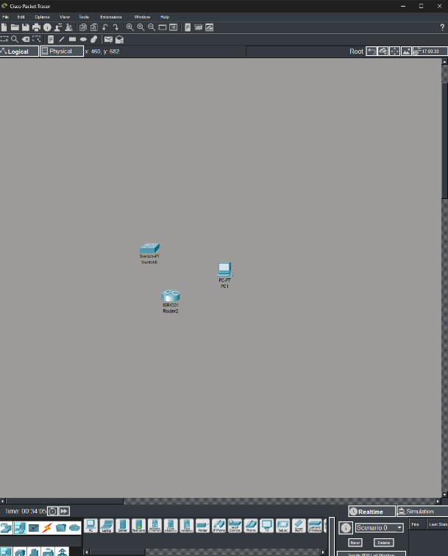
Simulation mode. As it shows packet level activity in slow motion, allowing me to see exactly how protocols interact, how devices forward frames, and how errors occur.

In this project, I practiced adding devices to the workspace and explored key tools like the Physical tab and Simulation Mode. I gained a better understanding of how Packet Tracer simulates real networking environments, which will help me in future projects where I build and configure networks.

Capstone Project 2: Build a MAC Address Table in Packet Tracer
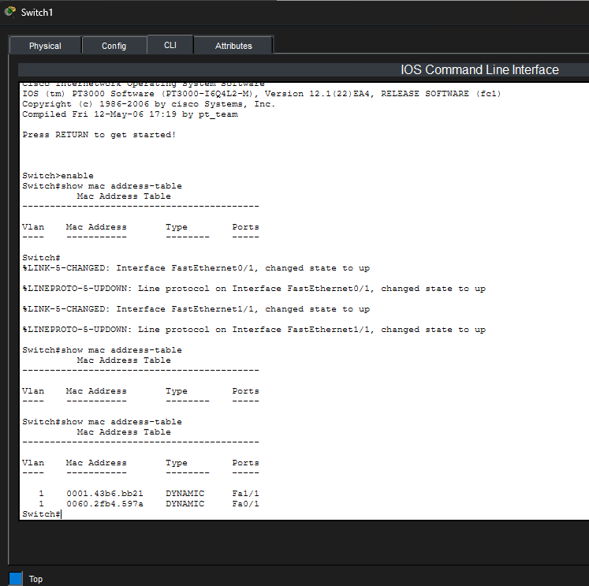
• How many devices is Switch0 currently aware of?
PC0 (Fa0/1), PC2 (Fa4/1), Switch1 (Fa4/1)
• Which device is connected to Switch0’s Fa0/1 interface? How can you confirm which device matches this MAC address?
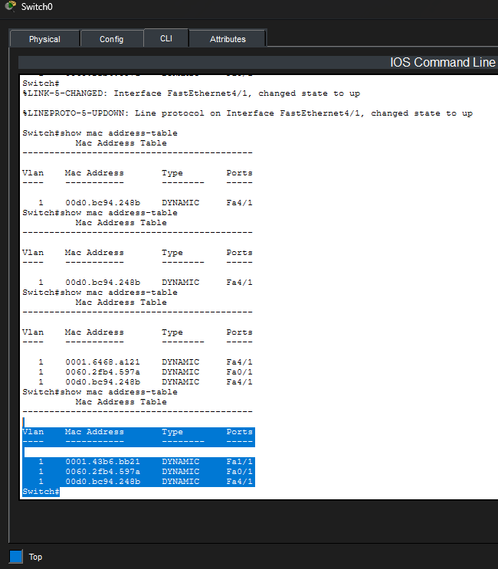
PC0 is connected to Fa0/1. I can confirm because PC0 is physically connected to Fa0/1. The mac address under Fa0/1 matches PC0’s NIC.
Figure 1 Step 24
Figure 2
• Which two devices communicated across Switch0’s Fa4/1 interface?
Switch1 and PC2 through switch1

Project 3: Repair a Duplicate IP Address
My IP: 10.0.0.4
Other deice IP: 10.0.0.1
• Has your computer identified the duplicate IP address problem yet? How do you know?
Because it marked 10.0.0.1 as “Duplicate” and assigned an APIPA address.
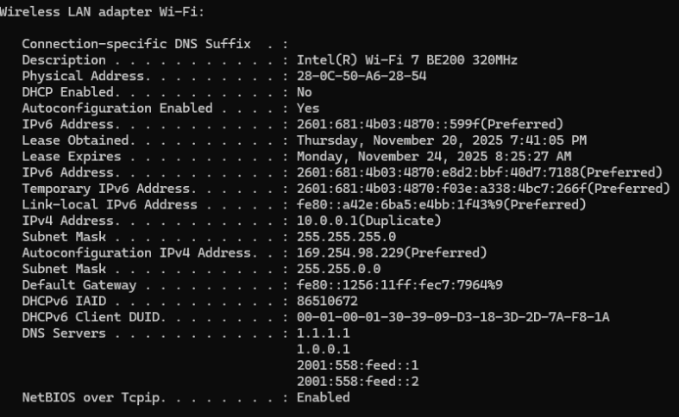
• Your computer might also have autoconfigured another IP address. If so, what address did your computer resort to?
Figure 3 Duplicate IP
169.254.98.229
How can you tell this is an APIPA address?
It is in range 169.254.0.0 to 169.254.255.255, which Windows automatically assigns when a device cannot obtain or use a valid IPv4 address.
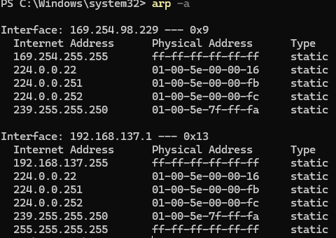
What are two ways to solve this problem?
Figure 4 Auto assigned APIPA
- Changing one of the devices to use different unique static IP addresses.
- Setting the device to obtain its IP address automatically (DHCP)
How many APIPA addresses appear?
1 (My own: 169.254.98.229)
Figure 5 Auto assigned APIPA
Which APIPA address belongs to you?
169.254.98.229
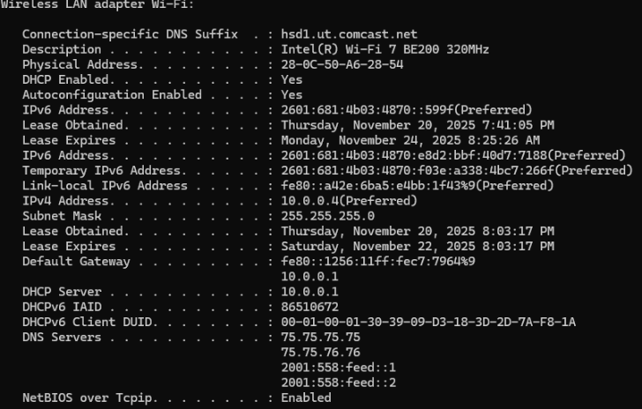
How many digits are the same across the APIPA addresses?
Since I completed this project individually as I was not able to get in touch with other group member, only my APIPA address (169.254.98.229) appears.
What is the new IP address?
10.0.0.4

